|  |  |
| --- | --- |
| Date | 29 October 2022 |
| Team ID | PNT2022TMID00315 |
| Project Name | IOT based Smart Crop Protection System for Agriculture |
| Maximum Marks | 4 Marks |

# 

**DATA FLOW DIAGRAM:**

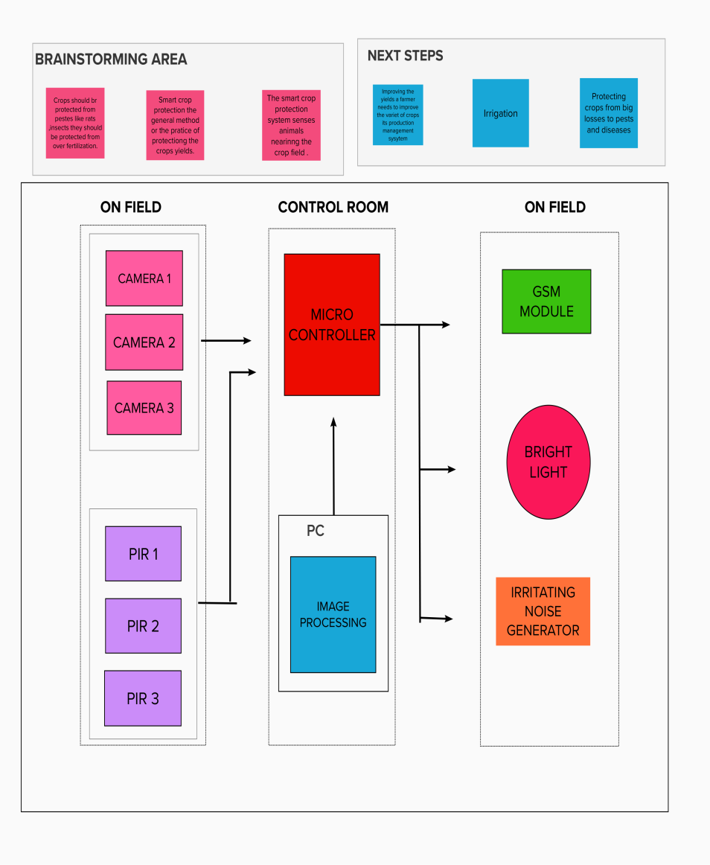

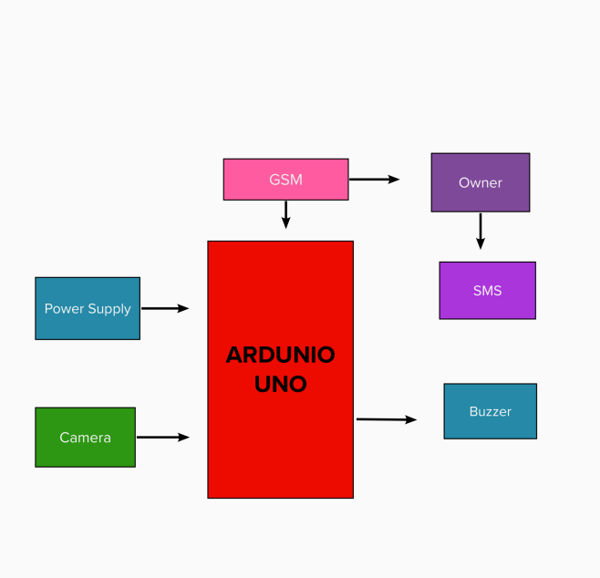**Simpliﬁed Diagram:**

* This framework runs on an Arduino Uno and makes use of a microcontroller.
* This framework makes use of a PIR sensor to detect intruders close to the field and a temperature and humidity sensor in addition to that to preserve soil moisture.
* When animal and birds approach close to the PIR(passive infrared Sensor), it detects the movement birds or animals
* The microcontroller receives the input signal after it has been processed further after being received from the warm body.
* The system will then be turned on, at which point a buzzer will sound and an SMS will be sent to the user.
* Microcontroller (Arduino Uno) is used for reading the inputs from PIR .
* The temperature sensor can help to maintain the amount of water in the soil and is used to keep the soil moist.
* The GSM module is used for sending SMS to user.

# User Stories:

|  |  |  |  |  |  |  |
| --- | --- | --- | --- | --- | --- | --- |
| **User type** | **Functional Requirement** | **User Story Number** | **User Story / Task** | **Acceptance criteria** | **Priority** | **Release** |
| User | Data collecting | USN-1 | Smart farming based IOT | gathering and preserving agricultural information. | High | Sprint-4 |
|  |  | USN-2 | I will alert the farmer to protect the crops as a user. | I can inform the farmer. | Medium | Sprint-2 |
|  |  | USN-3 | Extract data from source. | Management of data through expert and investigation method | High | Sprint-2 |
| User 2 | Login | USN-4 | I am able to alert the farmers because I am a co-user. | I am able to warn farmers. | High | Sprint-1 |
| Farmer | Login | USN-5 | As a farmer, I'll take the path to the crop that will help me avoid or spot animal interference. | The crops are in my reach. | High | Sprint-2 |
| Crop Protector |  | USN-6 | crop protection measure. | In can protect the crop. | Medium | Sprint-2 |
| Farmer | Login | USN-7 | I can oversee the crop and assure the sanitary procedure in my capacity as a supervisor. | I am able to keep everything moving smoothly. | High | Spirit-1 |
| Crop yielder | Register | USN-8 | I can produce more crop as a yielder.. | Smart Crop can be registered by me. | Medium | Spirit-3 |
| Crop Monitor |  | USN-9 | I monitor the quality of IIOT devices as a crop monitor. | I can examine the IOT gadget. | Medium | Spirit-3 |